NAME :G. AKSHAYA COURSE CODE : CSA0619
REG NO: 192521156 COURSE NAME : DESIGN AND ANALYSIS OF ALGORITHMS
CO2 - ASSESSMENT TOOL – 02

2. A logistics company manages 500 warehouse locations. To optimize delivery routes, the system calculates the distance between every pair of warehouses to identify the closest pair. As the number of warehouses increases, the system becomes slower.

Introduction

Efficient warehouse management is an important part of modern logistics and supply chain operations. A logistics company may operate hundreds of warehouse locations across different regions, and identifying the closest pair of warehouses helps reduce transportation time, minimize fuel costs, improve inventory transfers, and optimize delivery routes. To determine the closest pair, the system calculates the distance between every possible pair of warehouses.
One of the simplest methods for solving this problem is the Brute Force approach. This method compares each warehouse with every other warehouse and computes the distance between them using the Euclidean distance formula. Although the brute-force algorithm is easy to understand and guarantees the correct result, it performs a large number of comparisons as the number of warehouses increases. For example, with 500 warehouses, the algorithm performs 124,750 distance calculations, which significantly increases the execution time.
The time complexity of the brute-force approach is O(n²), meaning that the number of operations grows quadratically with the number of warehouses. As a result, the algorithm becomes less efficient and faces scalability issues when applied to large datasets. This analysis explains the working of the brute-force approach, derives its time complexity, and discusses why it is not suitable for large-scale logistics systems despite its simplicity and accuracy.
Problem Statement

A logistics company operates 500 warehouse locations across different regions. To improve delivery efficiency, the company needs to identify the closest pair of warehouses so that goods can be transferred quickly and transportation costs can be minimized. The system calculates the distance between every possible pair of warehouses. As the number of warehouses increases, the execution time also increases significantly, making the system slower. This problem demonstrates how the Brute Force algorithm works and why its performance decreases with larger datasets.
a) Explain how the brute-force approach works in this case
The brute-force approach is the simplest method for solving the closest pair problem. It checks every possible pair of warehouses without using any optimization techniques.
Each warehouse is represented by its coordinates (x, y) on a map. The algorithm calculates the distance between one warehouse and every other warehouse using the Euclidean distance formula. After calculating each distance, it compares the result with the smallest distance found so far. If a smaller distance is found, it updates the minimum distance and stores the corresponding warehouse pair. This process continues until every possible combination has been examined.
Since every warehouse is compared with all other warehouses exactly once, the algorithm always finds the correct closest pair. However, it performs many unnecessary calculations when the number of warehouses becomes very large.
Step-by-Step Working:
- Read the coordinates of all warehouses.
- Initialize the minimum distance as infinity.
- Select the first warehouse.
- Compare it with every remaining warehouse.
- Calculate the distance using the Euclidean distance formula.
- If the calculated distance is smaller than the current minimum, update the minimum distance.
- Repeat the process for all warehouses.
- Display the closest warehouse pair and the minimum distance.
Euclidean Distance Formula:
Distance=(x2​−x1​)2+(y2​−y1​)2​

Example:
Consider five warehouses
Warehouse | Coordinates
W1 | (2,3)
W2 | (5,6)
W3 | (8,10)
W4 | (3,4)
W5 | (9,7)

The algorithm performs the following comparisons:
- W1–W2
- W1–W3
- W1–W4
- W1–W5
- W2–W3
- W2–W4
- W2–W5
- W3–W4
- W3–W5
- W4–W5
Total comparisons:
25×4​=10
After calculating all distances, the pair having the smallest distance is selected.

Advantages
- Very easy to understand.
- Simple to implement.
- Always produces the correct answer.
- No preprocessing is required.
- Works well for small datasets.

Disadvantages
- Large number of comparisons.
- High execution time.
- Not suitable for large datasets.
- Consumes more CPU resources.
- Performance decreases rapidly as data size increases.

b) Derive the Time Complexity

Assume there are n warehouses.
The outer loop selects each warehouse one by one.
for i = 1 to n-1
For each warehouse, the inner loop compares it with all remaining warehouses.
for j = i+1 to n
Therefore,

T(n)=2n(n−1)​

Expanding,

T(n)=2n2−n​

Ignoring constants and lower-order terms,

T(n)=O(n2)

Hence, the brute-force algorithm has a quadratic time complexity.

Number of Comparisons:
Warehouses (n) | Comparisons
10 | 45
50 | 1,225
100 | 4,950
500 | 124,750
1,000 | 499,500
2,000 | 1,999,000
5,000 | 12,497,500

This table clearly shows that the number of comparisons grows rapidly as the number of warehouses increases.
Best Case:
Even if the closest pair is found early, the algorithm still compares all pairs.
Time Complexity = O(n²)
Average Case:
Every pair is checked.
Time Complexity = O(n²)
Worst Case:
Every possible pair is checked before completion.
Time Complexity = O(n²)
Space Complexity1:
The algorithm stores only a few variables such as:
- Current minimum distance
- Current warehouse pair
- Loop variables
Therefore,
Space Complexity = O(1)

c) Discuss why scalability is an issue

Scalability refers to the ability of a system to handle increasing amounts of data without a significant drop in performance.
The brute-force algorithm is not scalable because the number of distance calculations increases quadratically.
For example:
- 100 warehouses require 4,950 comparisons.
- 500 warehouses require 124,750 comparisons.
- 1,000 warehouses require 499,500 comparisons.
- 5,000 warehouses require 12,497,500 comparisons.
As the number of warehouses increases:
- Processing time becomes much longer.
- CPU utilization increases.
- More power is consumed.
- The application becomes slower.
- Real-time route planning becomes difficult.
In large logistics companies managing thousands of warehouses, this algorithm becomes impractical. More efficient algorithms, such as the Divide and Conquer Closest Pair algorithm (O(n log n)), are preferred because they significantly reduce execution time while producing the same correct result.

Real-World Impact:

In logistics operations:
- Delivery scheduling may be delayed.
- Transportation costs can increase due to slower planning.
- Warehouse synchronization becomes inefficient.
- Customer orders may take longer to process.
- Real-time tracking and route optimization become less effective.
Source code:
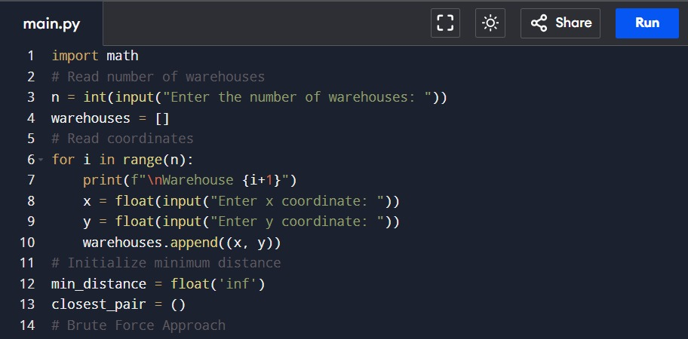

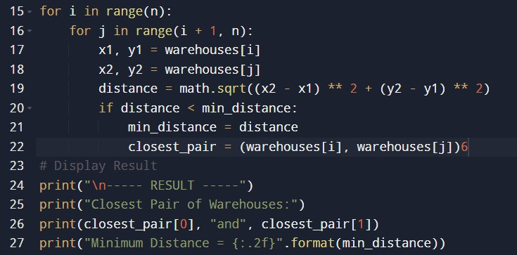

Sample input & output:

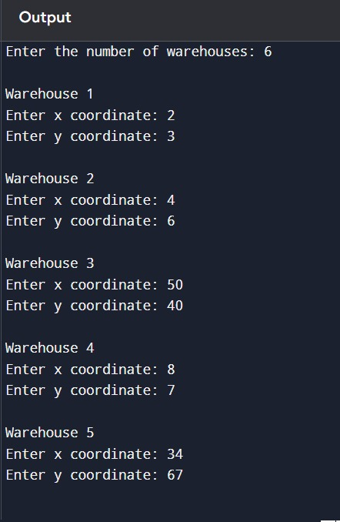
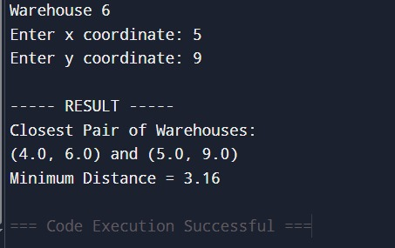

Conclusion:

The brute-force approach is an effective introductory algorithm for finding the closest pair of warehouses because it is simple to implement and guarantees the correct result. However, it performs 124,750 distance comparisons for just 500 warehouses, demonstrating its O(n²) time complexity. As the dataset grows, the execution time increases rapidly, making the algorithm unsuitable for large-scale logistics systems. Therefore, while brute force is useful for small datasets and educational purposes, practical logistics applications generally adopt more efficient algorithms such as Divide and Conquer to improve scalability and overall performance.

